State-Level, Monthly-Aggregated Daily Maximum Temperature Responses to Climate Change (Nature Data Draft)
Kenneth L. Cox, C. Adam Schlosser, Jennifer Morris, Xiang Gao

Abstract
Though average global temperature is expected to continue to rise, not all areas will experience the same temperature changes. Identifying and understanding which regions will undergo more warming than others is an important factor for adaptation and response measures. Daily maximum temperature is a key metric as it strongly correlates to human health and economic outcomes. In this study, we generate and analyze global warming-attributed trends in monthly-averaged maximum daily temperature across all states in the United States using linear regressions, with data drawn from the MERRA2 and ERA5 reanalysis datasets. Comparing which states and months experience stronger warming trends, we find the distribution is highly heterogenous, with sparse significant trends in February and May giving way to abundant significant warming trends throughout the summer months, especially September. Over the course of the year, Alaska, Utah, New Mexico, Colorado, and Nevada have the highest average warming trends, while Hawaii, Montana, North Dakota, South Dakota, and Arkansas have the lowest. This work assists in identifying the highest-risk regions to near-term warming, enabling policymakers to triage those states that will experience the most drastic temperature increases.
Table of Contents
State-Level, Monthly-Aggregated Daily Maximum Temperature Responses to Climate Change (Nature Data Draft) 1
Abstract 1
Background and Summary 2
T_{max, monthly} Trends Show Spatial and Seasonal Heterogeneity 3
A Web App for Visualization of Average Monthly Maximum, Mean, and Minimum Temperature Trends 10
Methods 12
Discussion 14
Appendix 15
Sensitivity of Clustering Results to the Number of Clusters 15
Regression Validations 18
ERA5 Regression Results Over the Full ERA5 Timeframe 20
Acknowledgements 21
References 22

Background and Summary
Average global temperature increase as the result of anthropogenic climate change is projected to drive local increases in daily minimum temperature (T_{min}), daily mean temperature (T_{mean}), and daily maximum temperature (T_{max}) (Collins et al. 2013). In turn, these increases have wide-ranging effects on ecosystems (García et al. 2018), electricity usage and the electrical grid (Molina et al. 2023; Gao et al. 2018), and crop productivity (Wheeler et al. 2000), among other areas. Understanding how this increase in average global temperature relates to increases in local temperature is necessary for mitigating the impact of these changes. Moreover, as predictions of global temperature increase carry uncertainty (Lee et al. 2023), it is also important to factor in this uncertainty into predictions at the regional level, and to account for uncertainty originating in policy decisions by analyzing regional temperature responses under different emissions scenarios.
Reanalysis data sets, such as MERRA2 and ERA5, have been used to substantiate past temperature trends and suggest future outcomes. Many reanalysis data sources contain high-resolution records over time periods long enough to capture anthropogenic forcings, making them ideal for studying local responses to global temperature trends (Fujiwara et al. 2017). However, many of these studies adopt a particular focus, examining temperature trends in specific regions like the Mississippi River basin (Tavakol et al. 2020), the Northeast (Hayhoe et al. 2008), Southeast (Powell and Keim 2015), and Midwest (Dai et al. 2016). Studies examining temperature trends across the U.S. (e.g. Portmann et al. 2009, Grotjahn and Huynh 2018) have not previously reported state-level aggregations for metrics such as daily high and low temperatures, which provide useful summaries for policymakers and the public.
We aim to complement these past studies with a complete analysis of temperature trends in all US states over each month. Using MERRA2 and ERA5 reanalysis data, we relate changes in average maximum daily temperature for each month and state in the United States to global temperature changes over the same period through linear regression models. After separate regressions are done for each dataset, the regression coefficients are combined via an inverse variance-weighted average, returning the best estimate of historical trends according to both datasets. Based on these historical trends, we generate predictions for future warming under a business-as-usual and policy scenario, with data derived from the MIT Earth Systems model (Sokolov et al. 2018). We also conduct a Mann-Kendall trend analysis, a standard test of time-series monotonicity in the literature (Almazroui and Şen 2020), to compare with the findings of our approach. Finally, we introduce a web-based tool that enables users to explore the past and predicted future evolution of T_{max}, T_{min}, and T_{mean} for individual states.
The choropleth map in Figure 1 displays both the spatial and temporal distributions of the pooled slope (i.e., the warming trend).
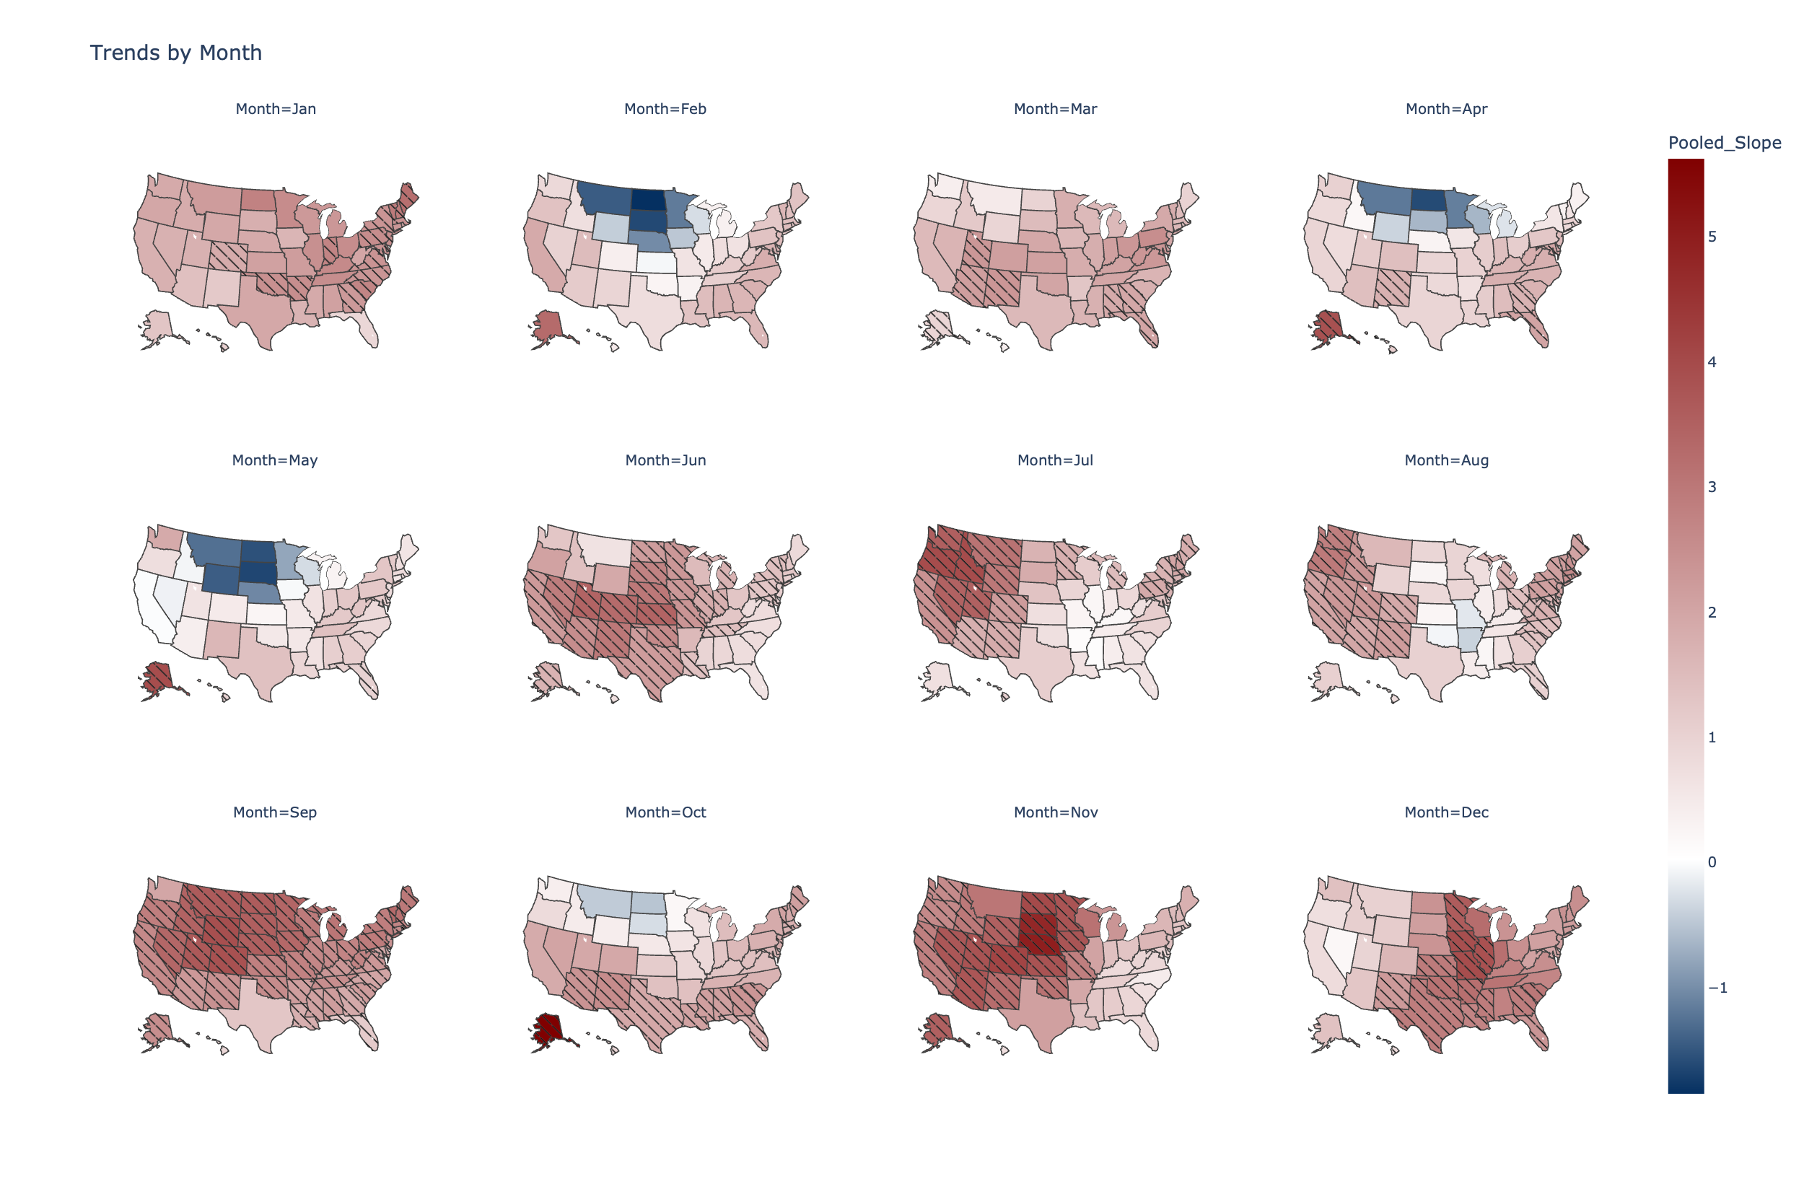
Figure 1. Results from a regression against monthly-averaged maximum daily temperature with global mean temperature (reporting inverse variance-weighted average slope between the ERA5 and MERRA2 datasets). Slopes are displayed for all 50 states in units of degrees of state-level monthly-averaged maximum daily temperature per degree of global mean temperature. Shading represents significance of the slope coefficient at α = 0.05 under a t-test, H₀: $\hat{β}$=0.
The observed warming displays geographic and temporal patterns. The Midwestern states experience very small trends that even slope negative from February-May; North Dakota and South Dakota in May display the sharpest downtrend overall, with approximately 1.6 degrees of cooling per degree of global warming. However, the weakness of the trend from January-April results in the actual magnitude of the trend to be insignificant, as statistical hypothesis testing demonstrates. These trends mostly reverse in the summer and the fall, with South Dakota in November showing a statistically significant warming of 4.8 degrees per degree of global warming. Other areas have less dramatic average inter-year variability. The Northeastern states generally stay within 1-3 degrees of local warming (with April-June as the most notable exceptions), while the Southern states often stay below 2 degrees of local warming (with September and December as the most notable exceptions).
To better characterize the spatial elements of the trends, Figure 3 breaks them down by region. The k-means clustering algorithm, a common unsupervised learning algorithm used to visualize climactic and temperature patterns (Kim and Kim 2023; Carvalho et al. 2016; Sathiaraj et al. 2019), was used to generate the map in Figure 3. The algorithm clustered states based on similarity in trends between months (the trend for each state was represented as a point in a 12-dimensional vector space, where each dimension corresponds to a month), and we specified the k-means algorithm to find 6 clusters. The clusters overlap somewhat with geographic regions in the US, with cluster 1 roughly corresponding to the Northeast, cluster 5 corresponding to the South and parts of the Midwest, Cluster 2 corresponding to the Middle Midwest, cluster 3 corresponding to the West, and cluster 4 corresponding to the Upper Midwest. However, the correspondence in each of these cases is not exact, and Alaska did not fit neatly into any of the other clusters. Supplementary Figure 1 in the Appendix contains two additional plots where the number of clusters was set to 4 and 5, as a test of the robustness of the clusters. Supplementary Figure 2 contains boxplots summarizing the distribution of trends within each cluster.
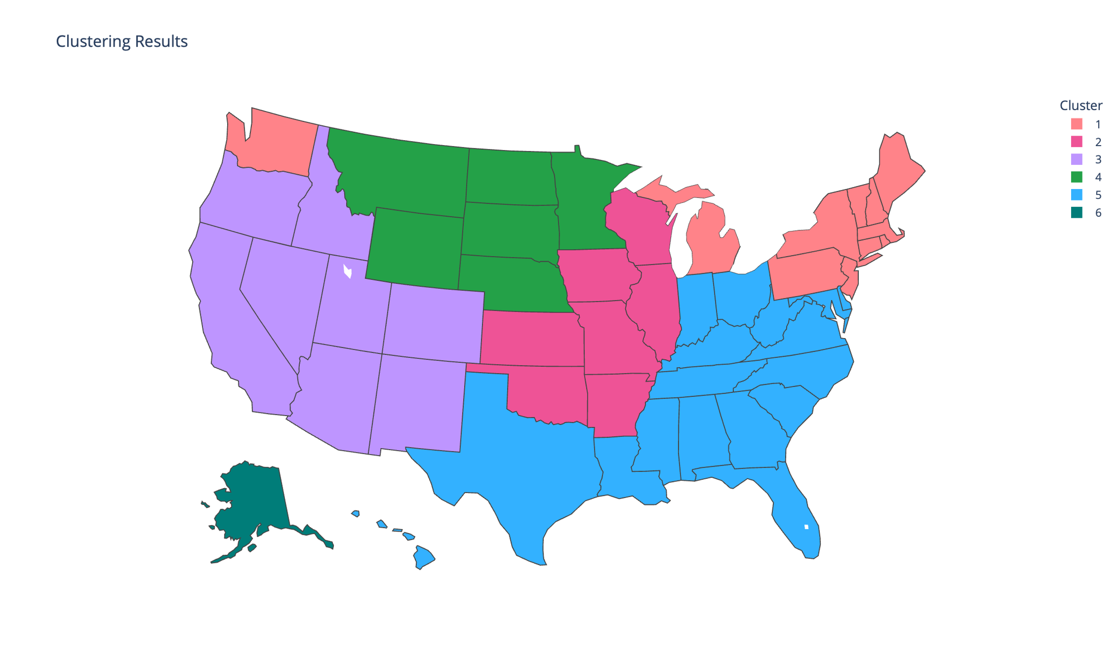
Figure 3. K-means clustering applied to the slopes from the regressions. Each state can be represented as a point in a 12-dimensional space, where each dimension corresponds to that state’s slope in each month of the year. The k-means clustering algorithm partitions the states into (in this case) 6 clusters based on how close each state’s slopes are to the centroid of each cluster, which is updated dynamically for each iteration of the algorithm.
The bar graph in Figure 4 displays the five states with the highest and lowest average trends. Alaska displays the highest historical warming, with an average of 2.9 degrees of monthly-averaged maximum daily temperature increase per degree of global warming, while Hawaii displays the lowest average historical warming, at 0.8.
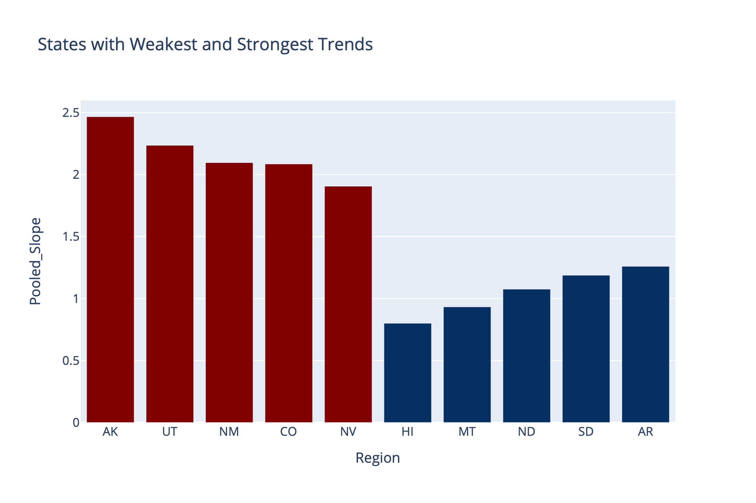
Figure 4. States with the largest and smallest overall warming trends on average. Alaska, Utah, New Mexico, Colorado, and Nevada have the highest average slopes (in red), while Hawaii, Montana, North Dakota, South Dakota, and Arkansas have the lowest (in blue).
We now turn to the temporal elements of the trend. Figure 5 breaks down the distribution of trends by month. The orange lines and text in the figure show the median slopes; the largest median increase in T_{max, monthly} occurs in September (2.63 degrees of local warming/degree of global warming), while the lowest occurs in May, with a median warming of 0.74 degrees/degree of global warming. Two month-to-month trends are surprising: first, a sharp drop-off in warming from January to February, and second, a warming spike in September.
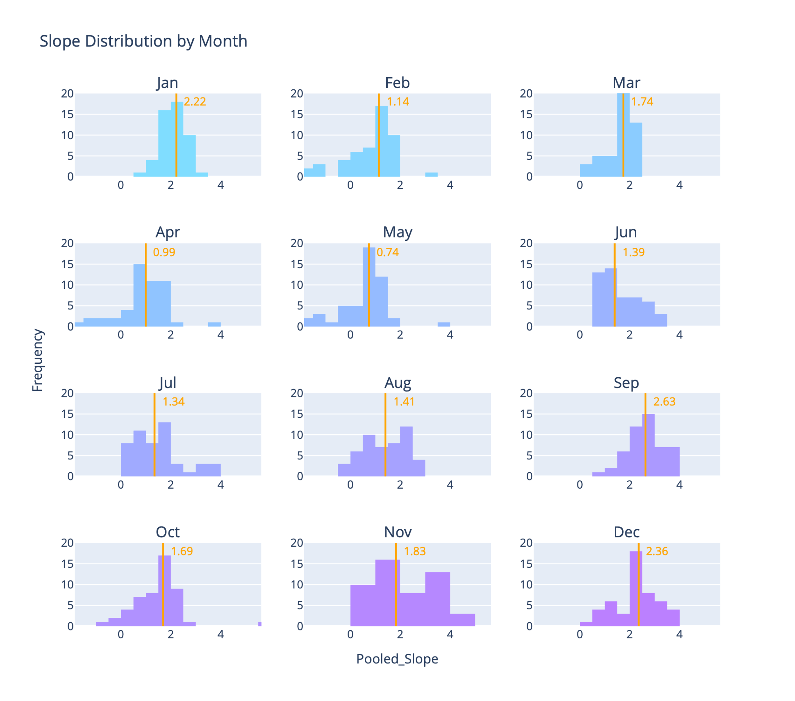
Figure 5. Distributions by month for the slopes of all 50 states. The orange line and text show the medians of the distributions.
To further confirm the presence of these trends, we conducted a Mann-Kendall test, a common nonparametric test of monotonic trends. As in other applications, the Mann-Kendall test of significance is paired with the Theil-Sen estimator, a nonparametric estimator of linear trends, to provide a visualization of where the strongest monotonic trends exist (Kliengchuay et al. 2024; Alemu and Dioha 2020). The plot of the Theil-Sen estimators, with significance established by the Mann-Kendall test, is given in Figure 6.
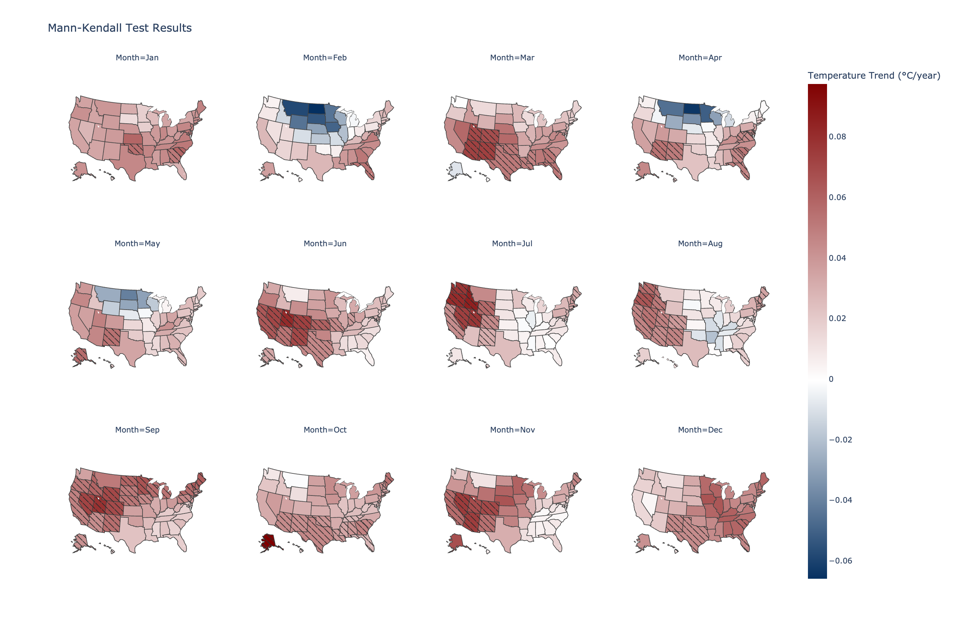
Figure 6. Value of Theil-Sen's estimator for the 50 states, a nonparametric estimator for monotonic trends. The value of the Theil-Sen estimator is the median slope of each pair of points in the data set, (y_{j} - y_{i})/(x_{j} - x_{i}), i ≠ j where y is the temperature variable and x is an index variable for years since 1980. Shaded states indicate significant monotonic trends as assessed by a Mann-Kendall test at a significance level of 0.05.

A Web App for Visualization of Average Monthly Maximum, Mean, and Minimum Temperature Trends
The results presented in this paper cover overall trends in average monthly maximum temperature for the US. So far, discussion of trends for specific states, and temperature projections in specific states under different socioeconomic assumptions, have largely been absent. To enable ease of visualization of both trends and projections for each state, we present a web app, available to Internet users and without a sign-up requirement. Users can select any state and view historical and projected future temperature data under a business-as-usual scenario and aggressive mitigation scenario. A screenshot of the web app is given in Figure () [will add this as soon as I update the app with mean and minimum temperatures].
The webapp produces figures similar to Figure 2, extended to include into the near future. The projections were generated using two 400-member ensembles of the MIT Earth Systems Model (MESM), one for a business-as-usual scenario, and one for an accelerated actions scenario. The evolution of the projections of those ensembles is given in Figure 9.
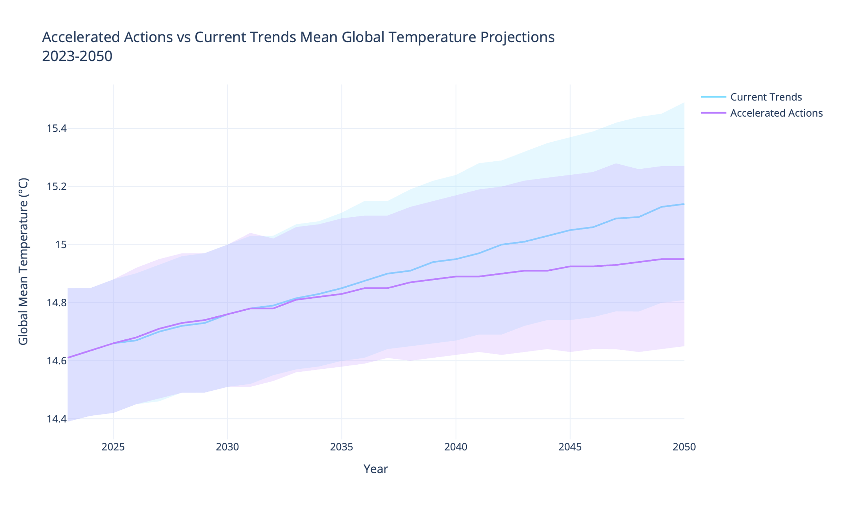
Figure 9. MESM projections for average global temperature through 2050 under a business-as-usual (Current Trends) and policy (Accelerated Actions) scenarios. The shaded regions correspond to the lower 5th percentile and upper 95th percentile of global mean temperature in the MESM ensembles.
To create future projections of local temperatures that accurately represent the uncertainty in both the regression coefficient and in MESM global average temperature projections, we use the Monte Carlo approach described in the Methods section. A plot like that shown in Figure 10 is produced for each state and each temperature condition (maximum, mean, minimum) and is available on the webapp.
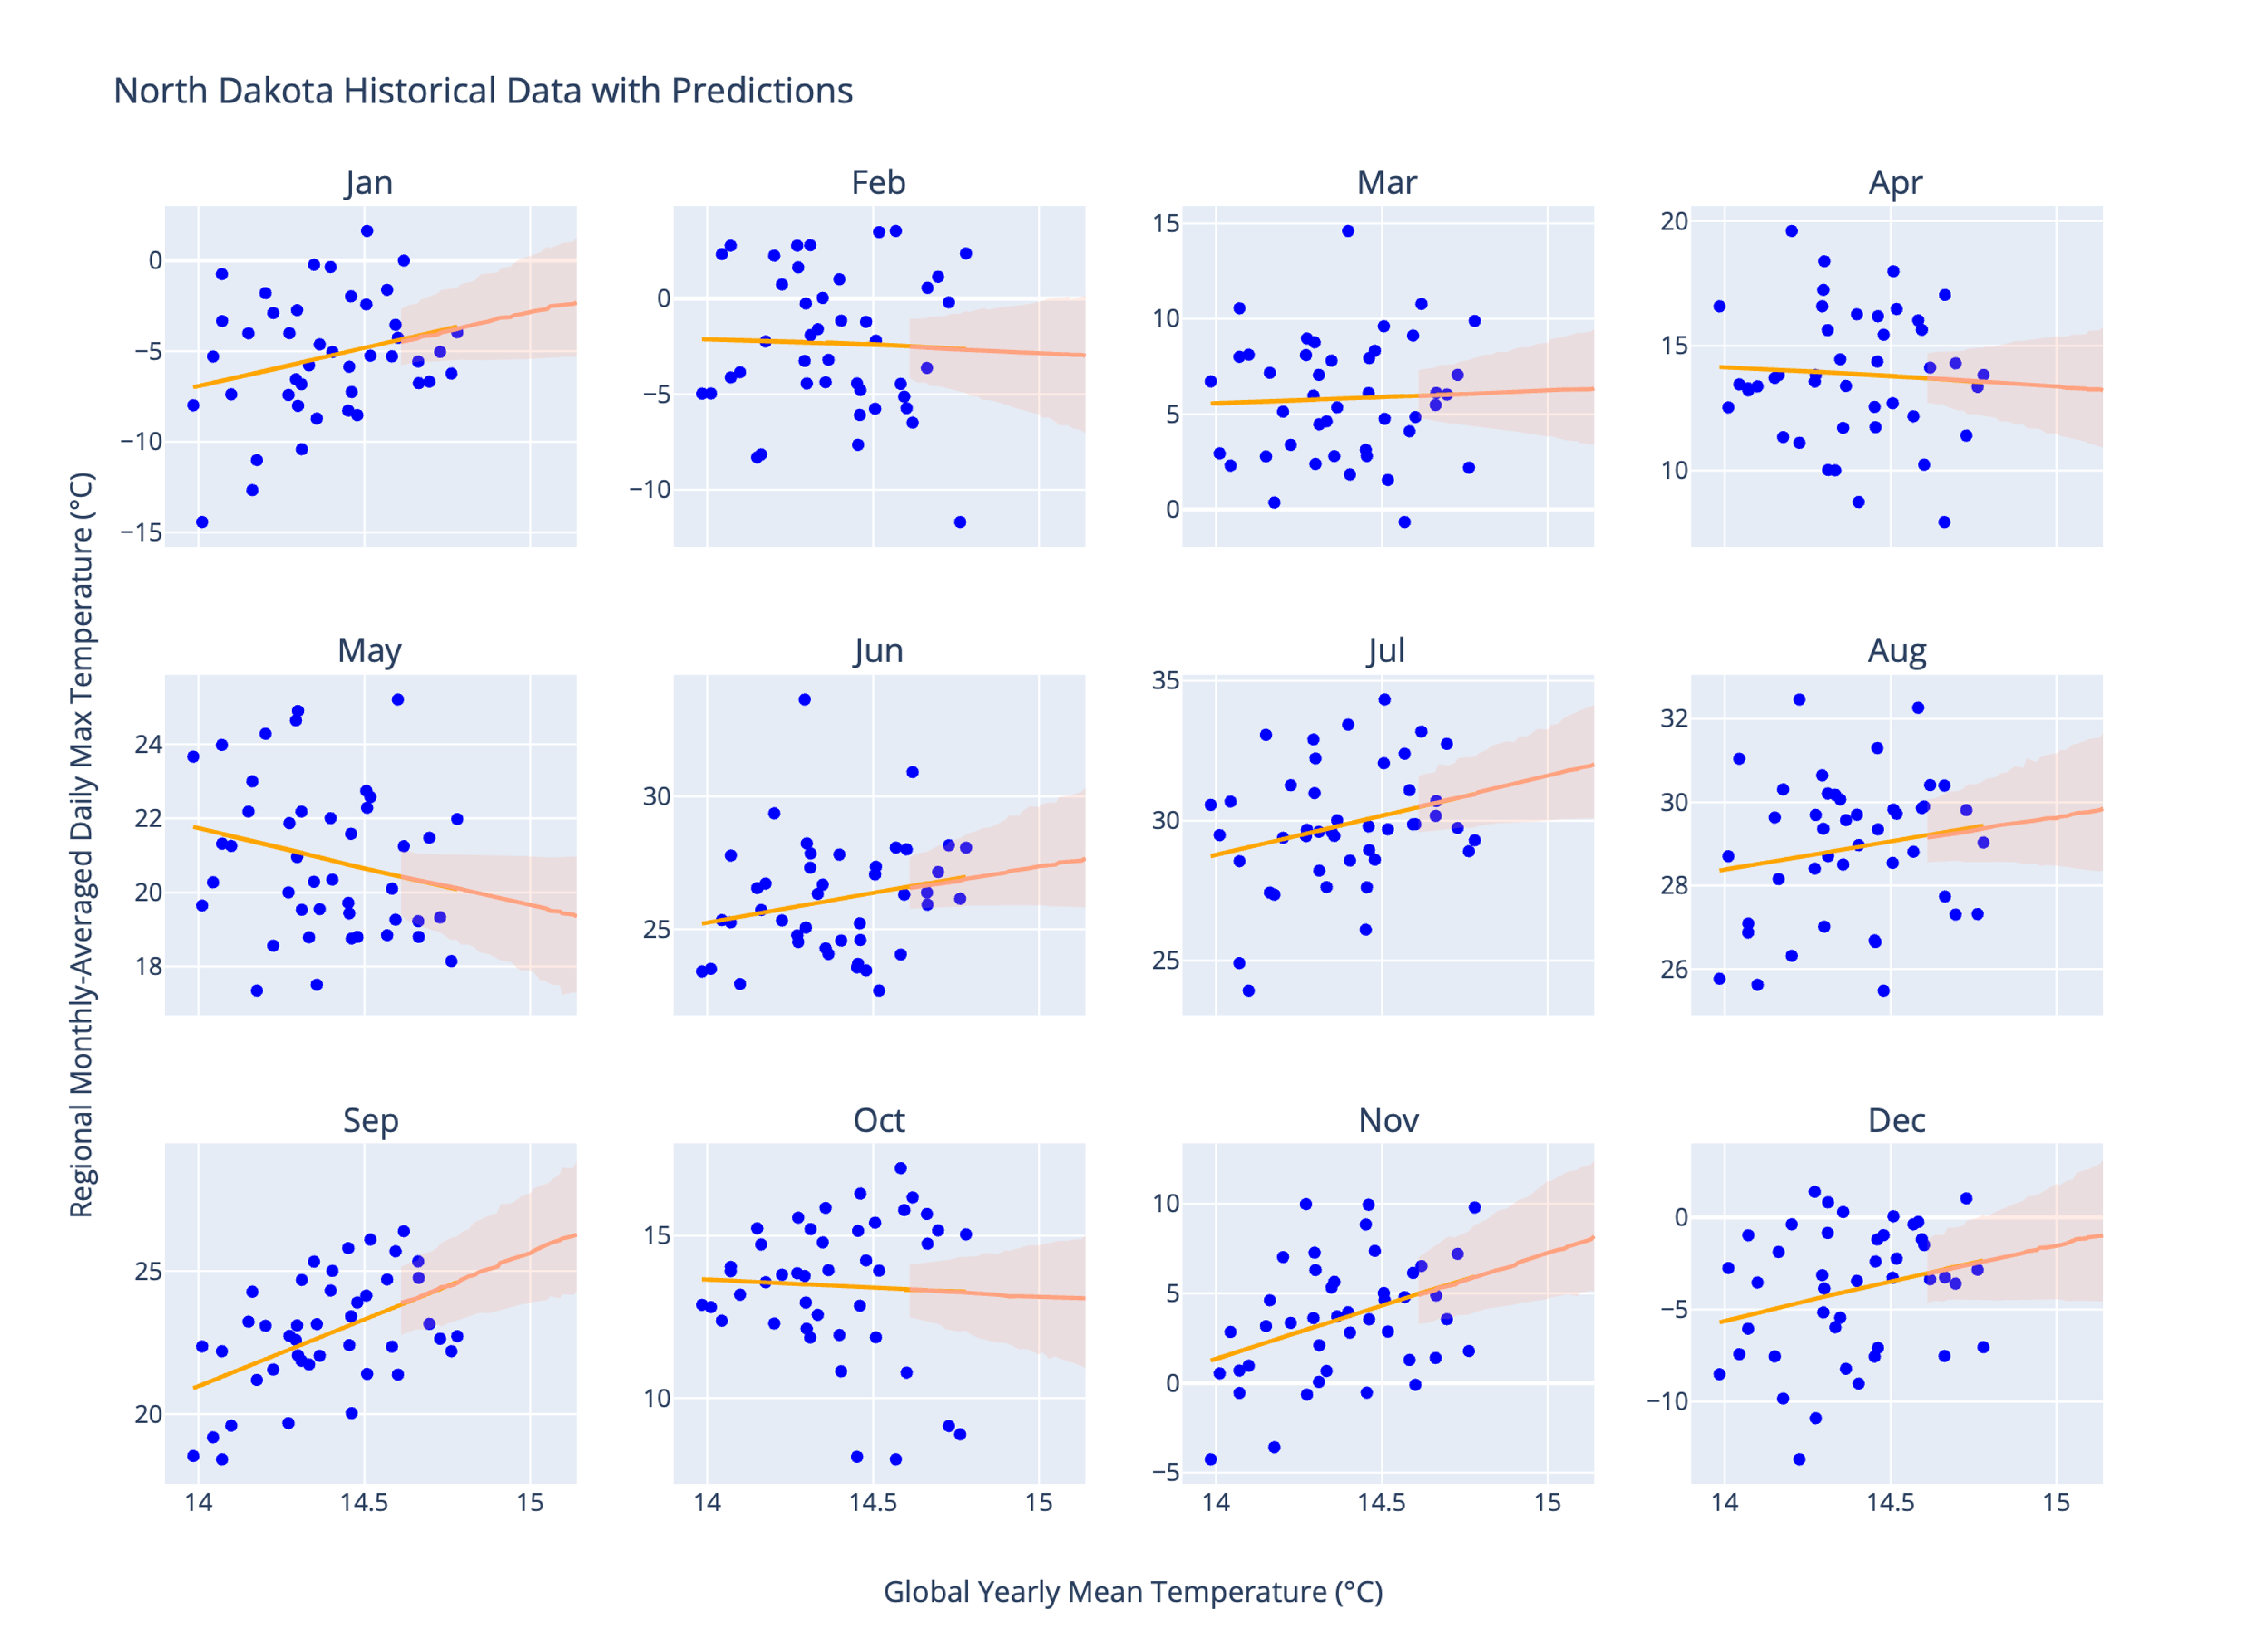
Figure 10. Regression results for North Dakota also showing projections for the near future (up to 2050) under the Current Trends (business-as-usual) scenario in MESM. The uncertainty bounds reflect the upper 95th and lower 5th percentiles of the projections, taking into account both uncertainty in the regression parameters and uncertainty in the yearly temperature projections.
The bounds in Figure 10 do not capture all the sources of uncertainty in the historical data. Because the regression uses only global mean temperature as a predictor variable, the variance explained in the regional temperatures is only explained by global mean temperature, excluding other factors that can affect regional temperatures. Therefore, the projections are best understood as the evolution of the trend (whether, for instance, it is likely that the trend will become negative in the near future if it is positive now), and not as a strong predictor of specific monthly temperatures. A validation analysis of the regression, showing its efficacy at predicting specific monthly temperatures, is provided in the Appendix.

Methods
This study combines the regression results of two datasets, ERA5 (ECMWF 2024) and MERRA2 (Global Modeling and Assimilation Office 2015), to provide the most robust estimates for the historical trends and future predictions. For each dataset, a time series of annually and globally averaged temperature (${\overline{T}}_{G}$) was constructed by first taking the area-weighted global average of the daily average temperature at 2m height instruments, over the period 1980-2022. Given that one of our goals was to extrapolate local trends out to the near future, we settled on using the yearly average global mean temperature as the predictor because it is the temperature variable returned by MESM.
Maximum daily temperatures averaged over each month (T_{max, monthly}), separately for each state in the US, were regressed against the global average temperature for the corresponding year, producing 12 regressions per state, per dataset. The regression slopes and intercepts from each dataset were averaged using an inverse-variance weighted approach (so the dataset with the most variance in the slope/intercept parameters would count less in the final model), and those averages are what is reported. To estimate the uncertainty in the regression parameters, we bootstrapped these regressions a total of 500 times. Whenever slopes are reported, they are in the original units (degrees of local monthly-averaged daily maximum temperature change per degree of global warming) unless otherwise indicated. The significance tests for the slopes are Wald tests, with the standard errors computed from the slope and intercept inverse variance-weighted averages over the 500 bootstraps.

Webapp
To visualize the uncertainty in the individual regressions, we construct both confidence intervals (capturing only the uncertainty in the predicted mean response) and prediction intervals (capturing the uncertainty for predicting a specific output value). use a Monte Carlo procedure to compute the upper and lower bounds of the entire regression model, including uncertainty from the global temperature projections. Future projections of yearly ${\overline{T}}_{G}$from MESM, of which there are 400, are standardized using the approach above and fed into the standardized regression model. This accounts for uncertainty in future global average temperature. To account for uncertainty in the regression model, 400 samples of the slope and intercept are drawn from the normal distribution described by the standard error of the mean and standard error of the intercept, both with mean 0. This approach results in the generation of three vectors of shape 400x1, one each for the slope, yearly ${\overline{T}}_{G}$ predictor, and the intercept. For every regression, the same vectors for slope and intercept are used (i.e. the samples are only drawn once, so they are not different each time). The corresponding 400 local temperature predictions (min, max, and mean) are then computed using
$${\overset{⃑}{T}}_{local, year}={\overset{⃑}{\hat{β}}}_{slope}*{\overset{⃑}{T}}_{MESM, year}+{\overset{⃑}{\hat{β}}}_{intercept}$$
where $*$ denotes element-wise multiplication of the vectors. Finally, these standardized results are converted back into the original unit configuration. Repeating this for each year (again using the same vectors ${\overset{⃑}{\hat{β}}}_{slope}$ and ${\overset{⃑}{\hat{β}}}_{intercept}$ for each year), we produce the full time series of predictions with uncertainty.
In this paper, we focus our results on T_{max, monthly}, although the webapp we will introduce can perform the same analyses for T_{mean, monthly} and T_{min, monthly}. There are many metrics that are fit to measure severity of extreme heat, such as 90th percentile T_{max}, wet bulb temperature, and absolute maximum daily temperature. T_{max, monthly} is a simple-to-interpret, useful metric that describes the upper bound of daily temperature while smoothing out daily and diurnal noise with the monthly aggregation.

Data Records
- Mention data availability once it’s determined where the data will be stored

Technical Validation

Usage Notes
- May not be a necessary section

Code Availability
- Github repo

References
Alemu, Zinabu Assefa, and Michael O. Dioha. 2020. “Climate Change and Trend Analysis of Temperature: The Case of Addis Ababa, Ethiopia.” Environmental Systems Research 9 (1): 27. https://doi.org/10.1186/s40068-020-00190-5.
Almazroui, Mansour, and Zekâi Şen. 2020. “Trend Analyses Methodologies in Hydro-Meteorological Records.” Earth Systems and Environment 4 (4): 713–38. https://doi.org/10.1007/s41748-020-00190-6.
Arthur, David, and Sergei Vassilvitskii. 2006. “K-Means++: The Advantages of Careful Seeding.” Techreport. Stanford, June 7. http://ilpubs.stanford.edu:8090/778/?ref=https://githubhelp.com.
Carvalho, M. J., P. Melo-Gonçalves, J. C. Teixeira, and A. Rocha. 2016. “Regionalization of Europe Based on a K-Means Cluster Analysis of the Climate Change of Temperatures and Precipitation.” Physics and Chemistry of the Earth, Parts A/B/C, 3rd International Conference on Ecohydrology, Soil and Climate Change, EcoHCC’14, vol. 94 (August): 22–28. https://doi.org/10.1016/j.pce.2016.05.001.
Collins, M., R. Knutti, J. Arblaster, et al. 2013. Chapter 12 - Long-Term Climate Change: Projections, Commitments and Irreversibility. Edited by IPCC. With M. R. Allen, T. Andrews, U. Beyerle, et al. Cambridge University Press. http://www.climatechange2013.org/images/report/WG1AR5_Chapter12_FINAL.pdf.
Copernicus Climate Change Service (C3S) Climate Data Store (CDS). 2024. “ERA5 Post-Processed Daily-Statistics on Single Levels from 1940 to Present.” https://doi.org/10.24381/cds.4991cf48.
Dai, Shuwei, Martha Shulski, Kenneth Hubbard, and Eugene Takle. 2016. “A Spatiotemporal Analysis of Midwest US Temperature and Precipitation Trends during the Growing Season from 1980 to 2013.” School of Natural Resources: Faculty Publications, January 1. https://digitalcommons.unl.edu/natrespapers/626.
Fujiwara, Masatomo, Jonathon S. Wright, Gloria L. Manney, et al. 2017. “Introduction to the SPARC Reanalysis Intercomparison Project (S-RIP) and Overview of the Reanalysis Systems.” Atmospheric Chemistry and Physics 17 (2): 1417–52. https://doi.org/10.5194/acp-17-1417-2017.
Gao, Xiang, C. Adam Schlosser, and Eric R. Morgan. 2018. “Potential Impacts of Climate Warming and Increased Summer Heat Stress on the Electric Grid: A Case Study for a Large Power Transformer (LPT) in the Northeast United States.” Climatic Change 147 (1–2): 107–18. https://doi.org/10.1007/s10584-017-2114-x.
García, Francisca C., Elvire Bestion, Ruth Warfield, and Gabriel Yvon-Durocher. 2018. “Changes in Temperature Alter the Relationship between Biodiversity and Ecosystem Functioning.” Proceedings of the National Academy of Sciences 115 (43): 10989–94. https://doi.org/10.1073/pnas.1805518115.
Global Modeling and Assimilation Office (GMAO). n.d. “Modern-Era Retrospective Analysis for Research and Applications, Version 2.” https://doi.org/10.5067/9SC1VNTWGWV3.
Grotjahn, Richard, and Jonathan Huynh. 2018. “Contiguous US Summer Maximum Temperature and Heat Stress Trends in CRU and NOAA Climate Division Data plus Comparisons to Reanalyses.” Scientific Reports 8 (1): 11146. https://doi.org/10.1038/s41598-018-29286-w.
Hayhoe, Katharine, Cameron Wake, Bruce Anderson, et al. 2008. “Regional Climate Change Projections for the Northeast USA.” Mitigation and Adaptation Strategies for Global Change 13 (5): 425–36. https://doi.org/10.1007/s11027-007-9133-2.
Kim, Yesuel, and Youngchul Kim. 2023. “Global Regionalization of Heat Environment Quality Perception Based on K-Means Clustering and Google Trends Data.” Sustainable Cities and Society 96 (September): 104710. https://doi.org/10.1016/j.scs.2023.104710.
Kliengchuay, Wissanupong, Rachaneekorn Mingkhwan, Nuttapohn Kiangkoo, et al. 2024. “Analyzing Temperature, Humidity, and Precipitation Trends in Six Regions of Thailand Using Innovative Trend Analysis.” Scientific Reports 14 (1): 7800. https://doi.org/10.1038/s41598-024-57980-5.
Lee, Hoesung, Katherine Calvin, Dipak Dasgupta, et al. 2023. “Synthesis Report of the IPCC Sixth Assessment Report (AR6), Longer Report. IPCC.” Monograph. Intergovernmental Panel on Climate Change (IPCC). https://mural.maynoothuniversity.ie/17733/.
Molina, M. O., C. Gutiérrez, M. Ortega, and E. Sánchez. 2023. “Summer Heatwaves, Wind Production and Electricity Demand in Southern Europe: Climatic Conditions and Impacts.” Environmental Research Communications 5 (8): 085005. https://doi.org/10.1088/2515-7620/acec37.
Portmann, Robert W., Susan Solomon, and Gabriele C. Hegerl. 2009. “Spatial and Seasonal Patterns in Climate Change, Temperatures, and Precipitation across the United States.” Proceedings of the National Academy of Sciences 106 (18): 7324–29. https://doi.org/10.1073/pnas.0808533106.
Powell, Emily J., and Barry D. Keim. 2015. Trends in Daily Temperature and Precipitation Extremes for the Southeastern United States: 1948–2012. Journal of Climate. February 15. https://doi.org/10.1175/JCLI-D-14-00410.1.
Sathiaraj, D., X. Huang, and J. Chen. 2019. “Predicting Climate Types for the Continental United States Using Unsupervised Clustering Techniques.” Environmetrics 30 (4): e2524. https://doi.org/10.1002/env.2524.
Sokolov, Andrei, David Kicklighter, Adam Schlosser, et al. 2018. “Description and Evaluation of the MIT Earth System Model (MESM).” Journal of Advances in Modeling Earth Systems 10 (8): 1759–89. https://doi.org/10.1029/2018MS001277.
Tavakol, Ameneh, Vahid Rahmani, and John Harrington. 2020. “Evaluation of Hot Temperature Extremes and Heat Waves in the Mississippi River Basin.” Atmospheric Research 239 (July): 104907. https://doi.org/10.1016/j.atmosres.2020.104907.
Wheeler, Timothy R, Peter Q Craufurd, Richard H Ellis, John R Porter, and P. V Vara Prasad. 2000. “Temperature Variability and the Yield of Annual Crops.” Agriculture, Ecosystems & Environment 82 (1): 159–67. https://doi.org/10.1016/S0167-8809(00)00224-3.

Acknowledgements

Author information

Ethics declarations

Supplementary information
In Figure 3, we presented results of a clustering analysis that enables an efficient visualization of which states contain the most similar temperature change patterns. Because the k-means algorithm used to create the clusters has random (although optimized) initialization using the k-means++ initialization algorithm (Arthur and Vassilvitskii 2006), there may be slightly different clustering results as the number of clusters is changed, and even within the same number of clusters. The randomness within the same number of clusters is accounted for by running k-means 10 times and choosing clusters based on which initial cluster centroids achieve the most stable results. The robustness of k-means with respect to the number of clusters is examined in Supplementary Figure 1, which contains clustering results using the same setup, differing only in the number of clusters selected (4 and 5).
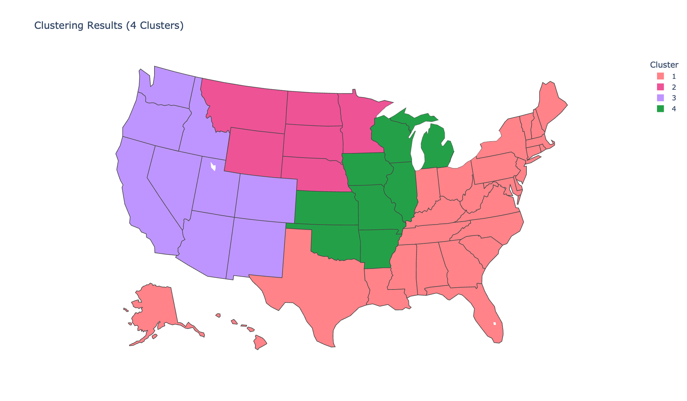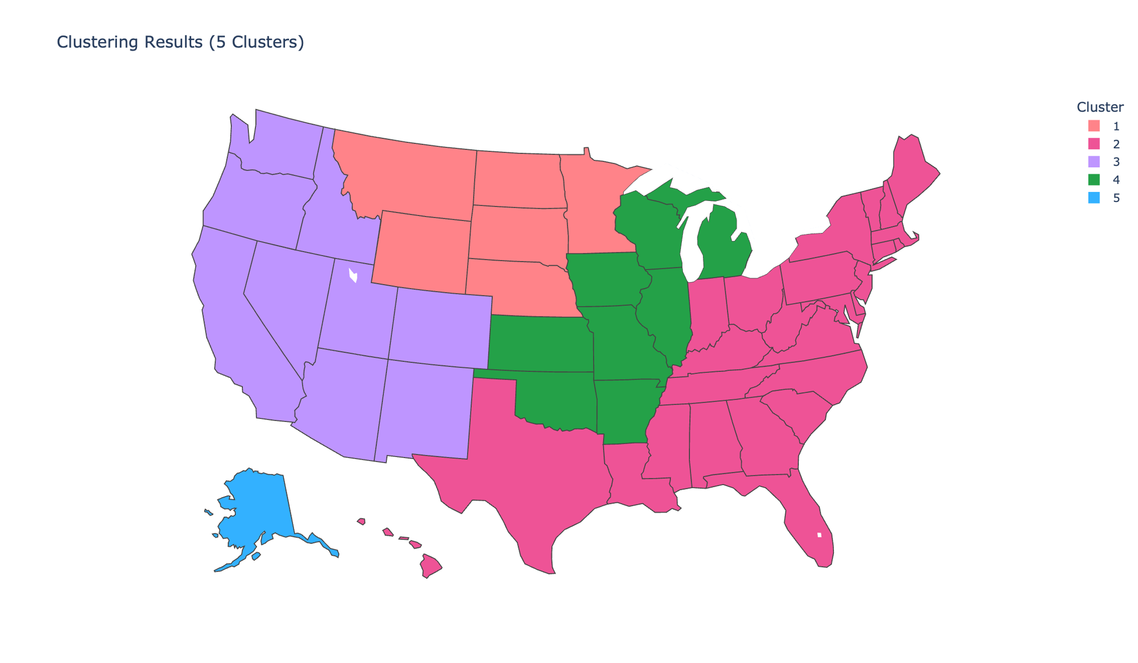
Supplementary Figure 1. Robustness of k-means clustering results to the number of clusters; the map to the left shows clustering results when the number of clusters is set to 4, and the map to the left shows the same when the number of clusters is set to 5.
While the clusters show groupings of similar states, they do not say how those states are similar. The boxplots in Supplementary Figure 2 provide a comprehensive overview of the summary statistics of the clusters.
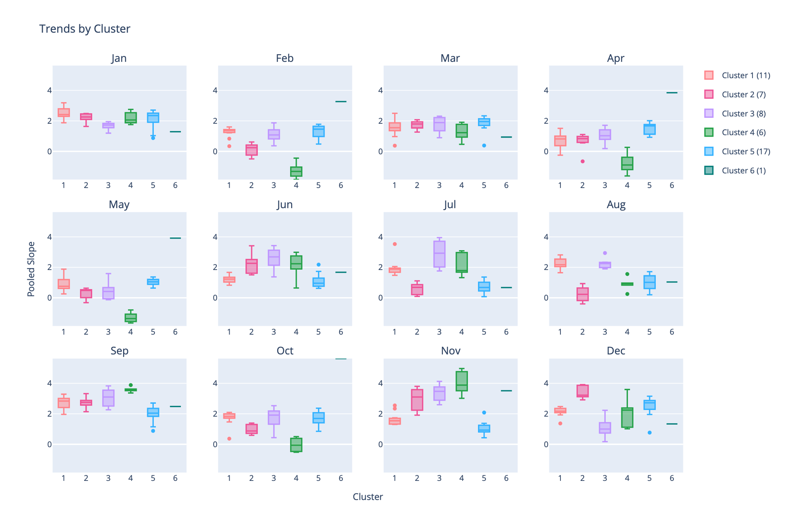
Supplementary Figure 2. Boxplots showing distribution summaries of each of the clusters from Figure 3.

- Popat for data
- Python packages
- Cite theil sen estimator
- Significance test for trends

